**Plant-bird interactions vary with microhabitats and season in a Californian dryland.**

Nargol Ghazian1*, Malory Owen1, and Christopher J.Lortie1

1Department of Biological Science, York University, 4700 Keele St, Toronto, ON M3J 1P3,

# *Corresponding Author: Department of Biological Science, York University, 4700 Keele St, Toronto, ON, M3J 1P3, Canada. Email: [nargolg1@my.yorku.ca](mailto:nargolg1@my.yorku.ca)

# ABSTRACT

Habitat heterogeneity is a critical mediator of animal community composition and structure in most ecosystems. Woody and dominant plants increase habitat heterogeneity and resources for animal communities through the provision of habitat, structure, and resources. However, interactions with plants can be species and life-stage-specific depending on the specific benefits provided to the animals. In this study, we examined the associational behaviour of bird species with dominant woody plant microsites. Phenological shifts that may influence these associations were taken into consideration by testing in different seasons. We tested the hypothesis that the composition and structure of bird communities are influenced by woody plants and that the frequency and nature of these associations (behaviour) will change depending on the season due to phenological shifts in fruiting and flowering. Line transects were used to record habitat associations of birds at a protected site in the Mojave Desert, CA, USA. We recorded variables such as species richness, abundance, behaviour, trophic guild, and the microhabitat at which the species was observed. Non-trophic interactions such as territorial behaviour/mating using woody plants comprised significantly more observed behaviours compared to trophic interactions, including feeding on fruits from plants. Diversity and evenness of the bird communities and territorial behaviours were significantly greater at shrubs microhabitats in the spring. In the summer, however, only the diversity of bird species was significantly greater at cacti and not at shrub or in the open. Hence, seasonal timing is an important component of the facilitation provided by dominant plants for bird communities in deserts. This study shows that non-trophic interactions with plants for habitat, shelter, and structure are important ecological mechanisms for maintaining local bird diversity in deserts.

**Keywords:** Arid, bird, cacti, community, desert, species diversity, facilitation, woody plant, habitat heterogeneity, microhabitat, non-trophic interactions, and behaviour.

# INTRODUCTION

Positive interactions are among the most important ecological interactions across communities. Facilitation at the landscape level can influence the ecosystem composition (Stachowicz 2001). Facilitation is defined as any positive interaction wherein a benefactor species increases the fitness or survival of the associated species (Bertness and Callaway 1994; Bruno et al. 2003). There are many mechanisms for facilitation (Landero and Valiente-Banuet 2010), and several categories are common across plant-animal interactions with plants often providing food resources such as nectar, fruit, and seeds (Narango et al. 2017; Feinsinger 1987; Saracco et al. 2004). Non-trophic interactions between dominant plants and animals are far less common with most studies examining hypotheses that support the function of shrubs as seed traps for beneficiary animals (Lortie et al. 2016). Dominant plants are also structural agents of amelioration from phenomena such as extreme climate, often having cooler and moister canopies (Filazzola et al. 2017). These trophic and non-trophic interactions are ecologically relevant for desert bird species; however, the relative frequency of these interactions within a given system or for a specific community is not well documented.

Vegetation is a key ecological component of deserts. Shrubs and cacti are dominant woody plants that have been documented as foundation species globally (Filazzola and Lortie 2014). These plants are key components of habitat infrastructure for wildlife throughout an ecosystem (Callaway 1997; Gelmi-Candusso et al. 2017). This physical stability helps maintain the presence of many other species in a habitat (Lortie et al. 2018). Plant-animal interactions are crucial components of deserts (Lortie et al. 2016; Bertness et al. 1999; Arsenault and Owen-Smith 2002). In relatively high-stress environments, such as deserts, events like mega-droughts and other inter-annual variations are stressful for many species (Siegal et al. 2013). A detailed understanding of the types of associations between dominant plant species and animals will enable better predictions of how biodiversity will respond to a changing climate and the relatively extreme existing variation in desert climates seasonally. The species specificity of positive interactions is also an important ecological issue (Callaway 1998; Villarreal-Barajas and Martorell 2009) because we need to know whether the benefits are generic and thus more easily restored and managed or specific to certain dominant plants.

Birds can be used as indicator species for ecosystem health because they are easily monitored and respond to large and small-scale changes in the environment (Carignan and Villard 2002). Bird behaviour and interactions with dominant plants can be examined to give us insight into the impacts of environmental change (García-Navas et al. 2021). In drylands, environmental changes are often unpredictable in time and space, and this variability can lead to migration (Salewski and Bruderer 2007) or nomadism (Teitelbaum and Mueller 2019). Migration is a long-distance movement where individuals or populations seasonally move between discrete locations, producing within- but not between-year variability in location and movement patterns (Teitelbaum and Mueller 2019). Conversely, nomadism is the movement of populations or individuals between locations with irregularity in timing and direction, producing both within-year and between-year variability in location and movement patterns (Teitelbaum and Mueller 2019). This study was not designed to differentiate these two movement processes common in desert avian communities. Secondly, the timing of life cycles in desert ecosystems can vary widely due to the extreme variation in temperature and precipitation inherent in these climates (Lortie 2022). Migration or nomadism can introduce differences in the associations between woody plants and birds in deserts (Ramos-Robles et al. 2016). Timing is critical for animals that rely on or associate with plants for resources (nectar, fruit, seeds, etc.) (Buler et al. 2007), specifically, floral and fruiting timing of plants (Schwartz 2003; Beatley 1974; Jordan and Nobel 1982; Nobel and Hartsock 1981) can have direct consequences for birds during migration breeding seasons (Sillett and Holmes 2002; Runge and Tulloch 2017; Fahse et al. 1998). Examining associational behaviours of the avian community with dominant plants provides us with details such as whether they are trophic or non-trophic, in addition to insight into temporal and seasonal variations that can influence these dynamics.

Fluctuations in climate can mean the loss of plant-bird interactions. The changes in these desert systems will further intensify the frequency, strength, and duration of severe weather events such as droughts (Ye and Grimm 2013), mega-droughts (i.e. long-term sustained inter-annual drought events) (Williams et al. 2020), and significant warming of annual temperatures (Kunkel et al. 2013). If dominant plants, such as foundation plants, are extirpated or become functionally extinct locally, other species can also disappear (Berger et al. 2008; Säterberg et al. 2013). Furthermore, if positive effects are specific to certain functions provided by species or even their unique architecture, then their loss can ultimately translate to the loss of the associated taxa. Hence, it is crucial to study desert plants and climate effects as climate influences species and consequently the interactions between them. Desert bird communities have already severely collapsed, primarily due to desert climate change (Iknayan and Beissinger 2018). Many of these threatened plant-bird interactions are species-specific and thus cannot be restored after their disappearance (Valiente-Banuet et al. 2015). Hence, it is important to determine how climate can impact species-specific interactions in drylands.

In this study, we examined the association pattern of dominant woody plant species with the avian community to examine variations by microhabitats and season. We tested the hypothesis that dominant plant species influence key avian community assembly measures and that these interactions are dependent on season. The benefits of habitat heterogeneity provided by different plant species can vary by season and year. Many key ecological processes provided by plant species to animals must be tested to understand and infer resilience and sensitivity to a changing climate because the inter-species and intra-species interactios are both directly influenced by environmental change (Valiente-Banuet et al. 2015; García-Navas et al. 2021; García-Girón et al. 2022). Additionally, understanding the importance of environmental change on species interactions is now more important than ever given the accelerated rates of anthropogenic impacts (Redlin and Gries 2021). Furthermore, the interaction between bird species and plants can also change by species and season and can include trophic feeding on fruits or non-trophic interactions. Thus, we made the following predictions: (1) The abundance (represented by a count of detections and observations but referred to as abundance in this study), richness, and diversity of a desert avian community are greater near dominant woody plant relative to open-gap microhabitats, and (2) bird-plant associations (behaviour) differ by season (spring versus summer) because of changes in the timing of flowering, fruiting, and presence of different bird species with varied needs to shelter and refuge, seasonally.

# MATERIALS & METHODS

## **Study Site**

The fieldwork was conducted at the Sweeney Granite Mountains Desert Research Center (34°48′20″N 115°39′50″W) in the Mojave Desert (Fig. 1). The elevation is 3600 meters and the total site area ranges from 1128 to 2071 hectares and is off-limits to the public, and thus safe from visitor disturbance (Natural Reserves System 2022). Rainfall varies significantly throughout the year with mean annual precipitation ranging from 34 to 310 mm per year (Urban et al. 2009). Typically, there is limited precipitation in the summer. The site is dominated by perennial woody and succulent shrubs, including *Cylindropuntia acanthocarpa, Yucca mohavensis, Larrea tridentata,* and *Ambrosia salsola, Pinus monophylla* (André 2006). Mojave Yucca has been included as a cactus in our study due to its succulent leaves ending in sharp points which make it functionally similar to other cacti in the region. There are 159 birds, 42 mammals, 35 reptiles, 2 amphibians, and 504 species of vascular plants in the reserve (Gurin et al. 2012; Frick and Tillotson; Stewart and Lappin 2008; André 2006).

**Study species**

There are primarily three dominant plants in the study sites we sampled. *Cylindropuntia acanthocarpa*, or Buckhorn Cholla, is a cactus with an irregular branching pattern (Pinkava 1999). *Larrea tridentata*, or Creosote Bush, is a large, long-lived deciduous shrub that is a reliable flower producer due to its low rainfall threshold (Bowers and Dimmitt, 1994). Furthermore, *Yucca schideigera*, or Mojave Yucca, is a flowering plant native to the region with several specialists and generalist relationships to the fauna of the region. These three are the most abundant plant species and accounted for the greatest number of interactions documented in this study (National Park Service 2022). All three of these species have been documented as ecological foundation species in the region (Smith 1995; Schafer et al. 2012). Flowering in the Mojave typically occurs during the spring (April/May) with fruiting directly following but these can vary based on the species (Jennings, 2001). During the spring surveys, these three species were flowering. Additionally, in the summer, all three foundation species were fruiting.

## **Experimental Design**

A 500-meter line transect was surveyed over two-hour period blocks to sample the bird community. The two hours either took place between 7-10 am or 5-8 pm, depending on daily temperatures. Two individual line transects were used and spaced 80 meters apart. The starting coordinates for transects 1 and 2 were (34.78299, -115.662) and (34.78303, -115.663), respectively. To avoid/reduce sampling bias in bird counts, we used line transects that covered a large area with 1-meter sub-divisions on each transect, a single observer with good knowledge of the local bird species, and repeated visits to maximize data accuracy (Manu and Cresswell 2007; Thompson 2002). There were a total of 27 surveys from 1/5/2019 to 10/5/2019 for spring observations and a total of 20 surveys for summer observations between 14/8/2019 to 24/8/2019. We elected to use data for species that we only directly observed as fine scales because we knew exactly how these individuals were associated with dominant woody plant species locally as this was not possible with auditory or heard-only. Microhabitats were defined as plants such as shrubs and cacti or open (Filazzola et al. 2017). Most non-shrub or non-cactus microhabitats constituted a relatively open area, however, some open microsites included spare, herbaceous but non-woody vegetation. Nonetheless, none of these open-gaps provided the high level of heterogeneity the dominant woody plants provided to their surroundings because dominant woody plant microhabitats are more heterogeneous than open spaces both vertically and in resources (Huenneke et al. 2001). We recorded behaviour using an a priori design ethogram to classify observations (Supplemental material A Table 1A). An Ethogram was constructed based on data from both seasons sampled. Data were recorded periodically whilst observing for interactions. Observed behaviours were also further simplified and categorized into trophic (fruits eaten) or non-trophic (using these plants in other ways) (Table A2 in Supplementary Material A). The microhabitat, geographic coordinates, and the time of the sighting were also recorded. Flyovers (defined as birds flying roughly ~8 meters above the highest vegetation at the site that did not land within sight) were not included in the observations.

Behaviour and microhabitat were treated as dependent variables for each independent bird observation documented. Behavioural observations were then categorized into broader behaviours (active movement, cleaning, feeding, inactive, and territorial/mating). Microhabitats were classified as cactus, shrub, or open-gap. Trophic guild and migratory class abundances, defined as the number of individuals within a trophic guild or migratory class at a seasonal microhabitat during a particular survey, were used to define functional diversity in further detailed analyses. We categorized all observed species into trophic guilds using a standard source (De Graaf et al.1985) and into migratory classes using a local source (Gurin et al. 2012). The migratory class of avian species is a status defined using a combination of orders, families, and genera, for the particular species. We did not distinguish between the migratory and nomadic classes in this study (Teitelbaum and Mueller 2019). Taxonomic diversity was recorded at species level and is thus represented in the primary statistical analyses. Lastly, daily climate data were obtained from the local weather station deployed at the study site and maintained by the Western Regional Climate Center (<https://wrcc.dri.edu/weather/ucgr.html>; Lortie 2022).

## **Statistical analyses**

Generalized linear models (GLM) were used to model the relationship between variables, including bird abundance, richness, trophic guild abundance, migratory class by microhabitat type, and season. Maximum air temperature per hour, averaged for each season, alongside the survey replication served as random factors in a nested format to avoid pseudoreplication (Donald et al. 2001; Morris et al. 2014). Migratory status is an important category because it can impact species-level responses to phenology (Rubolini et al. 2010). Species, trophic guild, or migratory class abundance are defined in this study as the number of individuals represented in each species, trophic guild, or migratory class. Species richness is the number of species in a community (i.e. a seasonal microhabitat during one survey). Diversity is represented by the Shannon Index. Post-hoc analyses of marginalised means were done with the *emmeans* function (Lenth and Herve 2019) in R Version 4.2.2 (R Development Core Team 2022). We repeated these analyses excluding the Black-throated Sparrow because it made up ~36% of the total species observed. We did so to ensure that this abundant bird species was not unduly influencing detected outcomes. We also used a Non-metric Multidimensional Scaling analysis (NMDS) followed by a PERMANOVA (Legendre and Legendre 1998) to explore the influence of season on associations. Unlike GLMs that explore patterns in central tendency, NMDS explores patterns in the entire species assemblage (Minchin 1987). We ensured that iterations in NMDS were high enough to reduce stress as much as possible (Sheskin, 1997).

All R codes are openly published on Zenodo (Owen and Lortie 2020a). Photo documentation of all bird species is also published on Figshare (Owen 2020). Observational quantitative data are published on the Knowledge Network for Biocomplexity Data Repository (Owen and Lortie 2020b).

# RESULTS

*Avian Diversity*

A total of 755 birds were observed during both seasons over an entire duration of 94 hours. During the spring, 539 individual birds were visually observed, and 216 birds were visually observed in the summer. Thus, there were significantly more individual birds observed in spring than in summer (Fig. 2; Supplemental Material C Table C1; post-hoc contrast at p = 0.0327).

Avian communities associated with shrubs in spring were the most species-rich and diverse (Fig. 2; Supplemental Material C Table C1; GLM richness; p = 0.024; post-hoc contrast at p = 0.0144; GLM Shannon index; p = 0.0001; post-hoc contrast at p = 0.0038). Open microhabitats in summer had the lowest bird species richness and biodiversity across all census periods (Fig. 2; Supplemental Material C Table C1; Richness: GLM; p = 0.024; post-hoc contrast at p < 0.0001; Shannon index: GLM; p = 0.0001; post-hoc contrast at p = 0.0216). The total abundances of birds were, however, greatest at open microhabitats in summer and lowest at open microhabitats in spring (Fig. 2; Supplemental Material C Table C1; GLM; p = 0.0254; post-hoc contrast at p = 0.0327).

*Avian Community Composition*

All iterative analysis findings were robust that excluded the Black-throated Sparrow. Bird trophic guild abundances were highest at shrubs in spring (Fig. 2; Supplemental Material C Table C2; GLM; p = 0.0233; post-hoc contrasts at p = 0.0384, respectively). However, there was no difference in the abundance of birds by migratory class between microhabitats or by season (Fig. 2; Supplemental Material Table C Table C1; p = 0.318). There was no significant difference between the composition of the avian communities by season or by microhabitats (Supplemental Material B Table B2 and Figure B2; PERMANOVA; F2 = 1.523; R2 = 0.0081; p = 0.178). Stress for NDMS was nearly zero providing an excellent representation in reduced dimensions (Clarke 1993) (44 iterations, stress= 9.3 x 10-5; stress plot in Supplementary Material B).

*Avian Behaviour*

Non-trophic interactions such as territorial behaviour/mating (spring = 47.87%, summer = 34.72%) and movement (spring = 28.94%, summer = 30.1%) had greater proportions in the observed behaviours (Supplementary Material A Table A2). The only significantly different behavioural between the seasons was territorial being most frequent at shrubs in the spring (Fig. 3; Supplemental Material C Table C3; GLM; p-value < 0.0001; post-hoc contrast at p = 0.0291). Cleaning behaviours were the least common, and we observed cleaning at shrubs four times in spring and once in the summer (Fig. 3; Supplemental Material C Table C3; GLM; p-value < 0.0001; post-hoc contrast at p = 0.0291). Feeding, active, and cleaning behaviours in all communities were equally frequent (Fig. 3; Supplemental Material C Table C3; GLM; p-value < 0.0001); thus, there was no temporal effect for these factors. Spring sampling in 2019 was significantly cooler than summer sampling (GLM, X2 = 22.9, p-value <0.0001, *df* = 1; mean spring temperature = 60.9 °F ± 1.3 and mean summer temperature = 83.8 °F ± 0.60).

# DISCUSSION

Plant-animal interactions in deserts provide a key means to better understand associations amongst species in desert ecosystems. The hypothesis that dominant woody plants influence resident bird communities' assembly measures and that the interactions are season-dependent was supported in the Mojave Desert. The two ecological contexts (flowering and fruiting) that we predicted to influence positive outcomes for birds including species and seasonal specificity were also supported suggesting that these dynamics are consistent but warrant deeper examination. Avian species richness, diversity, and trophic guild abundances were higher at dominant plants. Diverse bird communities such as Verdin, Blue-Gray Gnatcatcher, and Ash-throated Flycatcher were most likely to be associated with shrubs rather than at open or cacti microhabitats in the summer. This suggests that dominant plant species effects are species-specific at a given site within a region, or that different species of birds use these habitats differently, and uniquely influence community composition (Ellison 2019). Both mechanisms were likely relevant drivers of the observed bird-plant association patterns in this system. Additionally, the mean frequencies of behaviours varied both by season and by microhabitat. Benefits estimated through observed behaviours were primarily non-trophic such as using plants for structural purposes as we observed increased territorial displays at shrubs in the spring. Thus, dominant woody plants are structural agents of facilitation that may aid in increasing the diversity of the local avian community through interactions with these microhabitats that differ seasonally.

Habitat heterogeneity, being fine-scale differences of habitats between microsites whether through space or vertical structure, was observed as important for bird community composition. Larger, more heterogeneous areas have more species of birds and birds can be more patchily distributed in heterogeneous areas (Freemark and Merriam 1986). Habitat attributes are key factors in structuring bird assemblages (Han et al. 2021). The lack of physical structure in the open microhabitats supported some birds though to a much lesser extent than shrubs and cacti in both spring and summer. Abiotic factors such as ultraviolet radiation, water scarcity, and heat are more intense in summer, which accounts for the lower diversity of many vertebrate species in open microhabitats in deserts (Koyama 2015). However, we observed some birds at cacti and open microhabitats as well because there are still seeds and nest sites available to birds (Simons and Martin 1990; Kelt et al. 2004). For example, when seeds and fruit begin to drop beneath the canopy of the mother plant (plant individuals that all other surrounding plants of the same species originate from), seed predators (i.e. granivorous birds) forage for these trophic resources (Racskó et al. 2007; Janzen 1970); but this is equally common in open areas (Milesi et al. 2019). There is both movement of resources and birds at these fine-scale contrasts. However, summer foraging at open sites was not observed in this study and thus is likely not a reason for desert birds to be in open sites, or this may be visual bias. While cacti can provide services like cover from predators and nesting sites to many species (Kozma and Mathews 1997), the family Cactaceae is morphologically diverse (Boke 1980) and unique cactus species thus provide functionally different opportunities for animals. The importance of cacti for birds in regions with other dominant cactus species has been well-documented (Drezner 2014). Furthermore, the use of vegetation where the structure is conducive to cooler temperatures is an important driver of habitat selection by birds, particularly during the warmest of days (Kline et al. 2019). Our findings suggest that it is hence not one or the other (shrub or cacti) that enhances community assembly, but in fact, it is the existence of both species in the area, as well as the open-gap, even in times of trophic resource abundance such as spring that contributes to heterogeneity - Heterogeneity itself is crucial for the maintenance of biodiversity in arid ecosystems.

Resource availability through summer fruits was not the primary driver of bird community diversity at shrub microhabitats. Birds in this system were typically observed associating with shrub microhabitats for their structural benefits such as for perching sites as territorial displays. Territorial displays allow birds to express honest signals to potential mates (Searcy et al. 2006) and provide population key information to conservationists such as reproductive status and population viability (Lewis et al. 2020). These findings support previous research that shrubs are valuable to migrating birds in the spring when they are seeking new territories (Lima 2009) and that perching sites are used differently for foraging and territorial displays (Collins 1981; Beck and George 2000). The expression of these behaviours is necessary for birds to maintain social connections and territories, both of which are important for bird reproductive success (Wilkins et al. 2013; Cooney et al. 2018). Birds likely associate more with dominant plants as they possibly provide structural resources through architecture, height, spatial continuity, or even the presence of some animals near them. Future work could examine the importance of structural characteristics for bird communities. Benefactor rocks have been shown to facilitate plants and provide a habitat for desert birds (Peters et al. 2008; Warning and Benedict 2015). Plant architecture, i.e. the nature and relative arrangement of a plant’s parts (Barthélémy et al. 2007), has already been documented as important for bird communities. For instance, perch height is an important influencer of bird aggression, and thus plant and branch height must continue to be explored. Anthropogenic development of the American Southwest has provided an abundance of structures that may be beneficial to birds, including fence posts and solar panels (Prather and Messmer 2010). This is not to say anthropogenic structures will ever provide a greater benefit than perching and heterogeneity offered via natural vegetation as artificial structures may have negative implications such as the loss of seed dispersal over a landscape as birds over-use towers and poles, as well as habitat loss. Careful attention should be paid to comparisons between these natural and non-natural or biotic and abiotic structures to see how these interactions are mixed, locally.

Environmental stress in desert ecosystems will increase with global change. Temporal environmental fluctuations influence bird diversity from spring to summer in deserts (Tonkin et al. 2017), and thus the decrease in bird individuals in summer supports research that has shown that bird species avoid areas with increased temperature during the summer season (Alonso et al. 2009). Increased seasonal temperatures in summer can cause birds to avoid hotter microsites in the open similar to reptiles (Albright 2017; Ivey et al. 2020). This is particularly important for smaller birds that lose water at a faster rate (Albright 2017). Open gaps between vegetation in deserts are particularly stressful for many animals and plants due to increased seasonal temperatures (Ivey et al. 2020; Lortie et al. 2016; Smith et al. 2018). Changes in biodiversity due to the arrival and departure of migratory species (in addition to anthropogenic impacts) have been shown to influence the success of resident species in reproduction and resource acquisition (Cox 1968; Greenberg et al. 1993; Ramírez-Cruz et al. 2020). This study supports other published work that has clearly documented avoidance by vertebrates of open gaps in desert summer landscapes (Gaudenti et al. 2021; Pike and Mitchell 2013). This suggests that many bird species rely on foundation plant species as perches and as shade to avoid experiencing the peak of some environmental stressors, such as temperature and solar radiation. Hence, we need to measure the effects of climate and the presence of foundation plant species in deserts when studying the conservation of bird species in these ecosystems. Both the species and the interactions between them are subject to global change drivers, and we must measure both the presence of species that interact and how they potentially support one another and associate in space and time seasonally.

Environmental managers and conservationists must make restoration decisions regarding planting, genetic provenance for restoration, and distribution of limited resources like seeds, seedlings, and fencing (amongst other things) to support plant growth (Aavik and Helm 2018). Developing spatial tools for seed sourcing for keystone species is also a critical decision in drylands (Shryock, DeFalco, and Esque 2018). Commonly, managers establish one easily accessible plant species that is functionally similar to a rarer plant to provide a microhabitat at lower costs and effort (Holl and Howarth 2000). However, birds require a range of microhabitats in environments with varying degrees of stress and varying types of pressures to exclude competitors. For successful, community-wide restoration efforts, this shifting range of needs must be fully considered. By protecting current plant diversity and investing in a diverse set of plant microhabitats when restoring degraded habitats, managers will better protect bird communities (Genes and Dirzo 2021). This study is a highly site-specific instance of plant-animal interactions and habitat heterogeneity. However, it provided a clear indicator of the capacity for woody plants to provide resilience to a changing climate in the Southwestern Northern America drylands for many bird species through physical refuge and shelter effects.

**ACKNOWLEDGMENTS**

We thank the Sweeney Granite Mountains Desert Research Station leadership Drs Jim André and Tasha La Doux for providing scientific and logistic support. The Anza-Borrego Foundation provided support through the Paul Jorgensen Bird Research Grant. CJL was supported by an NSERC and NG and MO were supported by FGS funding from York University.

The authors declare no conflicts of interest.

**AUTHOR’S CONTRIBUTIONS**

CJL and MO conceived the ideas and the experimental design; MO collected the data; MO analyzed the data with input from CJL; MO and NG wrote the manuscript; NG and CJL thoroughly edited the manuscript and contributed critically to drafts for publication.

**LITERATURE CITED**

Aavik, T., and A. Helm. 2018. Restoration of plant species and genetic diversity depends on landscape-scale dispersal. Restoration Ecology 26:S92–S102.

Albright, Thomas P., Denis Mutiibwa, Alexander. R. Gerson, Eric Krabbe Smith, William A. Talbot, Jacqueline J. O’Neill, Andrew E. McKechnie, and Blair O. Wolf. 2017. “Mapping Evaporative Water Loss in Desert Passerines Reveals an Expanding Threat of Lethal Dehydration.” *Proceedings of the National Academy of Sciences* 114 (9): 2283–88.

Alonso, Juan C., Carlos Palacín, Javier A. Alonso, and Carlos A. Martín. 2009. “Post-Breeding Migration in Male Great Bustards: Low Tolerance of the Heaviest Palaearctic Bird to Summer Heat.” *Behavioral Ecology and Sociobiology* 63 (12): 1705–15.

André, J. M. 2006. Vascular flora of the Granite Mountains. Crossosoma 32:38–74.

Arsenault, R., and N. Owen-Smith. 2002. Facilitation versus competition in grazing herbivore assemblages. Oikos 97:313–318.

Barthélémy, D., and Y. Caraglio. 2007. Plant architecture: A dynamic, multilevel and comprehensive approach to plant form, structure and ontogeny. Annals of Botany 99:375–407.

Beatley, J. C. 1974. Effects of Rainfall and Temperature on the Distribution and Behavior of Larrea Tridentata (Creosote-Bush) in the Mojave Desert of Nevada. Ecology 55:245–261.

Beck, M. J., and T. L. George. 2000. Song Post and Foraging Site Characteristics of Breeding Varied Thrushes in Northwestern California. The Condor 102:93–103.

Bergamo, P. J., N. Susin Streher, A. Traveset, M. Wolowski, and M. Sazima. 2020. Pollination outcomes reveal negative density-dependence coupled with interspecific facilitation among plants. Ecology Letters 23:129–139.

Berger, K. M., E. M. Gese, and J. Berger. 2008. Indirect effects and traditional trophic cascades: A test involving wolves, coyotes, and pronghorn. Ecology 89:818–828.

Bertness, M. D., G. H. Leonard, J. M. Levine, P. R. Schmidt, and A. O. Ingraham. 1999. Testing the relative contribution of positive and negative interactions in rocky intertidal communities. Ecology 80:2711–2726.

Boke, N. H. 1980. Developmental Morphology and Anatomy in Cactaceae. BioScience 30:605–610.

Bowers, J. E., and M. A. Dimmitt. 1994. Flowering Phenology of Six Woody Plants in the Northern Sonoran Desert. Bulletin of the Torrey Botanical Club 121:215–229.

Bruno, J. F., J. J. Stachowicz, and M. D. Bertness. 2003. Inclusion of facilitation into ecological theory. Trends in Ecology and Evolution 18:119–125.

Buler, J. J., F. R. Moore, and S. Woltmann. 2007. A multi-scale examination of stopover habitat use by birds. Ecology 88:1789–1802.

Callaway, R. M. 1997. Positive interactions in plant communities and the individualistic-continuum concept. Oecologia 112:143–149.

Callaway, Ragan M. 1998. “Are Positive Interactions Species-Specific?” *Oikos* 82 (1): 202.

Callaway, R. M. 2007. Positive Interactions and Interdependence in Plant Communities. First. Springer, Dordrecht.

Callaway, R. M., and L. R. Walker. 1997. Competition and facilitation: A synthetic approach to interactions in plant communities. Ecology 78:1958–1965.

Cárdenas, Sasha, Laura M. Cardona, Maria A. Echeverry-Galvis, and Pablo R. Stevenson. 2020. “Movement Patterns and Habitat Preference of Oilbirds (Steatornis Caripensis) in the Southern Andes of Colombia.” Avian Conservation and Ecology 15 (2): art5.

Carignan, V., and M.-a. Villard. 2002. Selecting Indicator Species to Monitor Ecological Integrity: A Review. Environmental Monitoring and Assessment 78:45–61.

Clarke, K. R. 1993. Non-parametric multivariate analyses of changes in community structure. Austral Ecology. 18, 117–43.

Collins, S. L. 1981. A comparison of nest-site and perch-site vegetation structure for seven species of warblers. Wilson Bull. 93:542–547.

Cooney, C. R., H. E. A. MacGregor, N. Seddon, and J. A. Tobias. 2018. Multi-modal signal evolution in birds: Re-examining a standard proxy for sexual selection. Proceedings of the Royal Society B: Biological Sciences 285.

Cox, G. W. 1968. The Role of Competition in the Evolution of Migration. Evolution 22:180–192.

De Graaf, R. M., N. G. Tilghman, and S. H. Anderson. 1985. Foraging Guilds of North American Birds. Environmental management 9:493–536.

Donald, P. F., D. L. Buckingham, D. Moorcroft, L. B. Muirhead, A. D. Evans, and W. B. Kirby. 2001. Habitat use and diet of skylarks Alauda arvensis wintering on lowland farmland in southern Britain. Journal of Applied Ecology 38:536–547.

Drezner, T. D. 2014. The keystone saguaro (Carnegiea gigantea, Cactaceae): A review of its ecology, associations, reproduction, limits, and demographics. Plant Ecology 215:581–595.

Ellison, A. M. 2019 iScience 13:254–268.

Fahse, L., W. R. J. Dean, and C. Wissel. 1998. Modelling the size and distribution of protected areas for nomadic birds: Alaudidae in the Nama-Karoo, South Africa. Biological Conservation 85:105–112.

Filazzola, A., and C. J. Lortie. 2014. A systematic review and conceptual framework for the mechanistic pathways of nurse plants. Global Ecology 23:1335–1345.

Filazzola, Alessandro, Michael Westphal, Michael Powers, Amanda Rae Liczner, Deborah A. (Smith) Woollett, Brent Johnson, and Christopher J. Lortie. 2017. “Non-Trophic Interactions in Deserts: Facilitation, Interference, and an Endangered Lizard Species.” *Basic and Applied Ecology* 20 (May): 51–61.

Freemark, Kathryn E., and H.G. Merriam. 1986. “Importance of Area and Habitat Heterogeneity to Bird Assemblages in Temperate Forest Fragments.” *Biological Conservation* 36 (2): 115–41.

Frick, W.F., and Tillotson, N.E. (n.d). A guide to the lizards of the Granite Mountains.

García-Girón, Jorge, Alfio Alessandro Chiarenza, Janne Alahuhta, David G. DeMar, Jani Heino, Philip D. Mannion, Thomas E. Williamson, Gregory P. Wilson Mantilla, and Stephen L. Brusatte. 2022. “Shifts in Food Webs and Niche Stability Shaped Survivorship and Extinction at the End-Cretaceous.” *Science Advances* 8 (49): eadd5040.

García‐Navas, Vicente, Thomas Sattler, Hans Schmid, and Arpat Ozgul. 2021. “Bird Species Co‐occurrence Patterns in an Alpine Environment Supports the Stress‐gradient Hypothesis.” *Oikos* 130 (11): 1905–18.

Gaudenti, Nicole, Emmeleia Nix, Paul Maier, Michael F. Westphal, and Emily N. Taylor. 2021. “Habitat Heterogeneity Affects the Thermal Ecology of an Endangered Lizard.” *Ecology and Evolution* 11 (21): 14843–56.

Gelmi-Candusso, T. A., E. W. Heymann, and K. Heer. 2017. Effects of zoochory on the spatial genetic structure of plant populations. Molecular Ecology 26:5896–5910.

Genes, L. and Rodolfo, D. 2022. “Restoration of Plant-Animal Interactions in Terrestrial Ecosystems.” *Biological Conservation* 265 (January): 109393.

Greenberg, R., D. K. Niven, S. Hopp, and C. Boone. 1993. Frugivory and Coexistence in a Resident and a Migratory Vireo on the Yucatan Peninsula. The Condor 95:990–999.

Gurin, C., T. La Doux, and S. Coe. 2012. Checklist for Birds of the Granite Mountains. Pages 79–84. First. Natural Reserve System University for California.

Han, Zheng, Lishi Zhang, Yunlei Jiang, Haitao Wang, and Frédéric Jiguet. 2021. “Local Habitat and Landscape Attributes Shape the Diversity Facets of Bird Communities in Inner Mongolian Grasslands.” Avian Conservation and Ecology 16 (1): art3.

Harris, J. A. 1916. The Variable Desert. The Scientific Monthly 3:41–50.

Henen, B. T., C. C. Peterson, I. R. Wallis, K. H. Berry, K. A. Nagy, K. H. Berry, and K. A. Nagy. 1998. Effects of Climatic Variation on Field Metabolism and Water Relations of Desert Tortoises. Oecologia 117:365–373.

Holl, K. D., and R. B. Howarth. 2000. Paying for restoration. Restoration Ecology 8:260–267.

Huenneke, L.F., Clason, D., and Muldavin, E. 2001. Spatial heterogeneity in Chihuahuan Desert vegetation: implications for sampling methods in semi-arid ecosystems. Journal of Arid Environments 47(3):257-270.

Iknayan, K. J., and S. R. Beissinger. 2018. Collapse of a desert bird community over the past century driven by climate change. Proceedings of the National Academy of Sciences of the United States of America 115:8597–8602.

Ivey, K. N., M. Cornwall, H. Crowell, N. Ghazian, E. Nix, M. Owen, M. Zuliani, C. J. Lortie, M. Westphal, and E. Taylor. 2020. Thermal ecology of the federally endangered blunt-nosed leopard lizard (Gambelia sila). Conservation Physiology 8:1–11.

Janzen, D. H. 1970. Herbivores and the number of tree species in tropical forests. The American Naturalist 104:501–528.

Jennings, W. Bryan. 2001. “Comparative Flowering Phenology of Plants in the Western Mojave Desert.” *Madrono* 48 (3): 162–71.

Jordan, P. W., and P. S. Nobel. 1982. Height distribution of two species of cacti in relation to rainfall, seedling establishment, and growth. Botanical Gazette 143:511–517.

Kahle, D., and H. Wickham. 2013. ggmap: Spatial Visualizations with ggplot2. The R Journal 5:144–161.

Kelt, D. A., P. L. Meserve, M. L. Forister, L. K. Nabors, and J. R. Gutiérrez. 2004. Seed predation by birds and small mammals in semiarid Chile. Oikos 104:133–141.

Kline, Holley N., Timothy E. Fulbright, Eric D. Grahmann, Fidel Hernández, David B. Wester, Leonard A. Brennan, and Michael W. Hehman. 2019. “Temperature Influences Resource Use by Chestnut-Bellied Scaled Quail.” *Ecosphere* 10 (2): e02599.

Kozma, J. M., L. M. Burkett, A. J. Kroll, J. Thornton, and N. E. Mathews. 2017. Factors associated with nest survival of Black-throated Sparrows, desert-breeding nest-site generalists. Journal of Field Ornithology 88:274–287.

Kunkel, K. E., L. E. Stevens, S. E. Stevens, and L. Sun. 2013. Regional Climate Trends and Scenarios for the U.S. National Climate Assessment: Part 4. Climate of the U.S. Great Plains.

Landero, J. P. C., and A. Valiente-Banuet. 2010. Species-specificity of nurse plants for the establishment, survivorship, and growth of a columnar cactus. American Journal of Botany 97:1289–1295.

Legendre, P., and L. Legendre. 1998. Numerical Ecology. Second editions. Elsevier Science, Amsterdam, The Netherlands. Lenth, R, and M Herve. 2019. *Emmeans, Estimated Marginal Means, Aka Least-Squared Means.* (version 1.1.2).

Lewis, R. N., L. J. Williams, and R. T. Gilman. 2020. The uses and implications of avian vocalizations for conservation planning. Conservation Biology 00:1–14.

Lortie, C.J. 2022. Climate data for Mojave National Preserve Granite Mountains 2019 ver 1. Environmental Data Initiative.

Lortie, C. J., A. Filazzola, and D. A. Sotomayor. 2016. Functional assessment of animal interactions with shrub-facilitation complexes: A formal synthesis and conceptual framework. Functional Ecology 30:41–51.

Lortie, C. J., E. Gruber, A. Filazzola, T. Noble, and M. Westphal. 2018. The Groot Effect: Plant facilitation and desert shrub regrowth following extensive damage. Ecology and Evolution 8:706–715.

Macías-Duarte, A., A. O. Panjabi, E. H. Strasser, G. J. Levandoski, I. Ruvalcaba-Ortega, P. F. Doherty, and C. I. Ortega-Rosas. 2017. Winter survival of North American grassland birds is driven by weather and grassland condition in the Chihuahuan Desert. Journal of Field Ornithology 88:374–386.

Manu, S, and Cresswell, W.R.L. 2007. “Addressing Sampling Bias in Counting Forest Birds: A West African Case Study.” Ostrich 78 (2): 281–86.

Minchin, P.R. 1987. “An Evaluation of the Relative Robustness of Techniques for Ecological Ordination.” In *Theory and Models in Vegetation Science*, edited by I. Colin Prentice and Eddy van der Maarel, 89–107. Dordrecht: Springer Netherlands.

Milesi, F. A., J. Lopez De Casenave, and V. R. Cueto. 2019. Are all patches worth exploring? Foraging desert birds do not rely on environmental indicators of seed abundance at small scales. BMC Ecology 19:1–17.

Mojave National Preserve Tract and Boundary Data. 2019.. NPS - Land Resources Division.

Morris, E. K., T. Caruso, F. Buscot, M. Fischer, C. Hancock, T. S. Maier, T. Meiners, C. Müller, E. Obermaier, D. Prati, S. A. Socher, I. Sonnemann, N. Wäschke, T. Wubet, S. Wurst, and M. C. Rillig. 2014. Choosing and using diversity indices: Insights for ecological applications from the German Biodiversity Exploratories. Ecology and Evolution 4:3514–3524.

Narango, D. L., D. W. Tallamy, and P. P. Marra. 2017. Native plants improve breeding and foraging habitat for an insectivorous bird. Biological Conservation 213:42–50.

“National Park Service-Mojave.” 2022. <https://www.nps.gov/moja/learn/nature/plants.htm>.

Nobel, P. S., and T. L. Hartsock. 1981. Shifts in the optimal temperature for nocturnal CO2 uptake caused by changes in growth temperature for cacti and agaves. Physiologia Plantarum 53:523–527.

Owen, M., and C. Lortie. 2020a. Mojave Desert Bird Survey Photos 2019.

Owen, M., and C. Lortie. 2020b. Desert Bird Microhabitat Associations Analyses.

Owen, M., and C. Lortie. 2020c. Mojave Desert Bird Microhabitat and Behavioral Line Transect Observations.

Peters, E. M., C. Martorell, and E. Ezcurra. 2008. Nurse rocks are more important than nurse plants in determining the distribution and establishment of globose cacti (Mammillaria) in the Tehuacán Valley, Mexico. Journal of Arid Environments 72:593–601.

Pike, D. A., and J. C. Mitchell. 2013. “Burrow-Dwelling Ecosystem Engineers Provide Thermal Refugia throughout the Landscape: Burrows as Thermal Refugia.” *Animal Conservation* 16 (6): 694–703.

Pinkava, D. J. 1999. Cactaceae Cactus Family: Part Three: Cylindropuntia (Engelm.) Knuth Chollas. Journal of the Arizone-Nevada Academy of Science 32:32–47.

Prather, P. R., and T. A. Messmer. 2010. Raptor and Corvid Response to Power Distribution Line Perch Deterrents in Utah. Journal of Wildlife Management 74:796–800.

R Development Core Team. 2020. *R* (version 4.0.2).

Racskó, J., G. B. Leite, J. L. Petri, S. Zhongfu, Y. Wang, Z. Szabó, M. Soltész, and J. Nyéki. 2007. Fruit drop: The role of inner agents and environmental factors in the drop of flowers and fruits. International Journal of Horticultural Science 13.

Ramírez-Cruz, G. A., I. Solano-Zavaleta, M. Méndez-Janovitz, and J. J. Zúñiga-Vega. 2020. Demographic and spatial responses of resident bird populations to the arrival of migratory birds within an urban environment. Population Ecology 62:105–118.

Ramos-Robles, Michelle, Ellen Andresen, and Cecilia Díaz-Castelazo. 2016. “Temporal Changes in the Structure of a Plant-Frugivore Network Are Influenced by Bird Migration and Fruit Availability.” *PeerJ* 4 (June).

Rubolini, D, N Saino, and Ap Møller. 2010. “Migratory Behaviour Constrains the Phenological Response of Birds to Climate Change.” *Climate Research* 42 (1): 45–55.

Runge, C., and A. I. T. Tulloch. 2017. Solving problems of conservation inadequacy for nomadic birds. Australian Zoologist 39:280–295.

Salewski, V., and B. Bruderer. 2007. The evolution of bird migration–A synthesis. Naturwissenschaften 94:268–279.

Saracco, J. F., J. A. Collazo, and M. J. Groom. 2004. How do frugivores track resources? Insights from spatial analyses of bird foraging in a tropical forest. Oecologia 139:235–245.

Säterberg, T., S. Sellman, and B. Ebenman. 2013. High frequency of functional extinctions in ecological networks. Nature 499:468–470.

Schafer, J. L., E. L. Mudrak, C. E. Haines, H. A. Parag, K. A. Moloney, and C. Holzapfel. 2012. The association of native and non-native annual plants with Larrea tridentata (creosote bush) in the Mojave and Sonoran Deserts. Journal of Arid Environments 87:129–135.

Schwartz, M. D. 2003. Phenology: An integrative environmental science. Pages 1–610. Second. Springer Science+Business Media, New York.

Searcy, W. A., R. C. Anderson, and S. Nowicki. 2006. Bird song as a signal of aggressive intent. Behavioral Ecology and Sociobiology 60:234–241.

Sheskin, David J. 1997. “Handbook of Parametric and Nonparametric Statistical Procedures.”

Shryock, Daniel F., Lesley A. DeFalco, and Todd C. Esque. 2018. “Spatial Decision-Support Tools to Guide Restoration and Seed-Sourcing in the Desert Southwest.” *Ecosphere* 9 (10): e02453.

Siegal, Z., H. Tsoar, and A. Karnieli. 2013. Effects of prolonged drought on the vegetation cover of sand dunes in the nw negev desert: Field survey, remote sensing and conceptual modeling. Aeolian Research 9:161–173.

Sillett, T. S., and R. T. Holmes. 2002. Variation in survivorship of a migratory songbird throughout its annual cycle. Journal of Animal Ecology 71:296–308.

Simons, L. S., and T. E. Martin. 1990. Food Limitation of Avian Reproduction: An Experiment with the Cactus Wren. Ecology 71:869–876.

Villarreal-Barajas, Tania, and Carlos Martorell. 2009. “Species-Specific Disturbance Tolerance, Competition and Positive Interactions along an Anthropogenic Disturbance Gradient.” *Journal of Vegetation Science* 20 (6): 1027–40.

Voulgarakis, and D. Watson-Parris. 2018. Understanding Rapid Adjustments to Diverse Forcing Agents. Geophysical Research Letters 45:12, 023–12, 031.

Smith, F. A. 1995. Den Characteristics and Survivorship of Woodrats (Neotoma lepida) in the Eastern Mojave Desert. The Southwestern Naturalist 40:366–372.

Stewart, G. R., and A. K. Lappin. 2008. Amphibians and reptiles of the Seychelles.

“Sweeney Granite Mountains Desert Research Center.” 2022. <https://ucnrs.org/reserves/sweeney-granite-mountains-desert-center/>.

Team, R. C. 2022. R: A Language and Environment for Statistical Computing. R Foundation for Statistical Computing, Vienna, Austria.

Teitelbaum, C.S., and Mueller, T. 2019. Beyond Migration: Causes and Consequences of Nomadic Animal Movements. Trends in Ecology & Evolution 34, 569-581.

Thompson, William L. 2002. “Towards Reliable Bird Surveys: Accounting for Individuals Present but Not Detected.” The Auk 119 (1): 18–25.

Thompson, D. B., J. H. Brown, and W. D. Spencer. 1991. Indirect facilitation of granivorous birds by desert rodents: experimental evidence from foraging patterns. Ecology 72:852–863.

Tonkin, J. D., M. T. Bogan, N. Bonada, B. Rios-Touma, and D. A. Lytle. 2017. Seasonality and predictability shape temporal species diversity. Ecology 98:1201–1216.

Urban, F. E., R. L. Reynolds, and R. Fulton. 2009. The Dynamic Interaction of Climate, Vegetation, and Dust Emission, Mojave Desert, USA. Pages 1–62 *in* F.-B. A. and M. A. De La Rosa, editors. Arid environments and wind erosion. Nova Science Publishers, Inc.

Valiente-Banuet, A., M. A. Aizen, J. M. Alcántara, J. Arroyo, A. Cocucci, M. Galetti, M. B. García, D. García, J. M. Gómez, P. Jordano, R. Medel, L. Navarro, J. R. Obeso, R. Oviedo, N. Ramírez, P. J. Rey, A. Traveset, M. Verdú, and R. Zamora. 2015. Beyond species loss: The extinction of ecological interactions in a changing world. Functional Ecology 29:299–307.

Warning, N., and L. Benedict. 2015. Overlapping home ranges and microhabitat partitioning among Canyon Wrens (Catherpes mexicanus ) and Rock Wrens (Salpinctes obsoletus ). The Wilson Journal of Ornithology 127:395–401.

Westphal, M. F., T. Noble, H. S. Butterfield, and C. J. Lortie. 2018. A test of desert shrub facilitation via radiotelemetric monitoring of a diurnal lizard. Ecology and Evolution 8:12153–12162.

Wilkins, M. R., N. Seddon, and R. J. Safran. 2013. Evolutionary divergence in acoustic signals: Causes and consequences. Trends in Ecology and Evolution 28:156–166.

Williams, A. P., E. R. Cook, J. E. Smerdon, B. I. Cook, J. T. Abatzoglou, K. Bolles, S. H. Baek, A. M. Badger, and B. Livneh. 2020. Large contribution from anthropogenic warming to an emerging North American megadrought. Science 368:314–318.

Ye, L., and N. B. Grimm. 2013. Modelling potential impacts of climate change on water and nitrate export from a mid-sized, semiarid watershed in the US Southwest. Climatic Change 120:419–431.

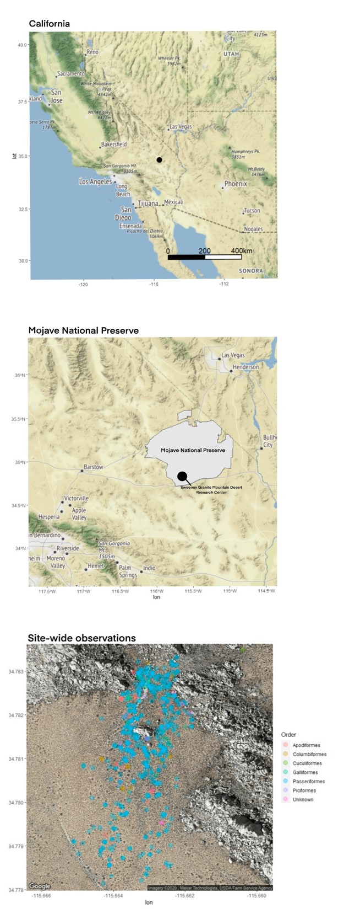**FIGURES**

**Figure 1.** Maps of American southwestern region, Mojave National Preserve, and study sit4e with all observations group by taxonomic order. Passiformes dominated this study (Kahle and Wickham 2013; Mojave National Preserve Tract and Boundary Data 2019).

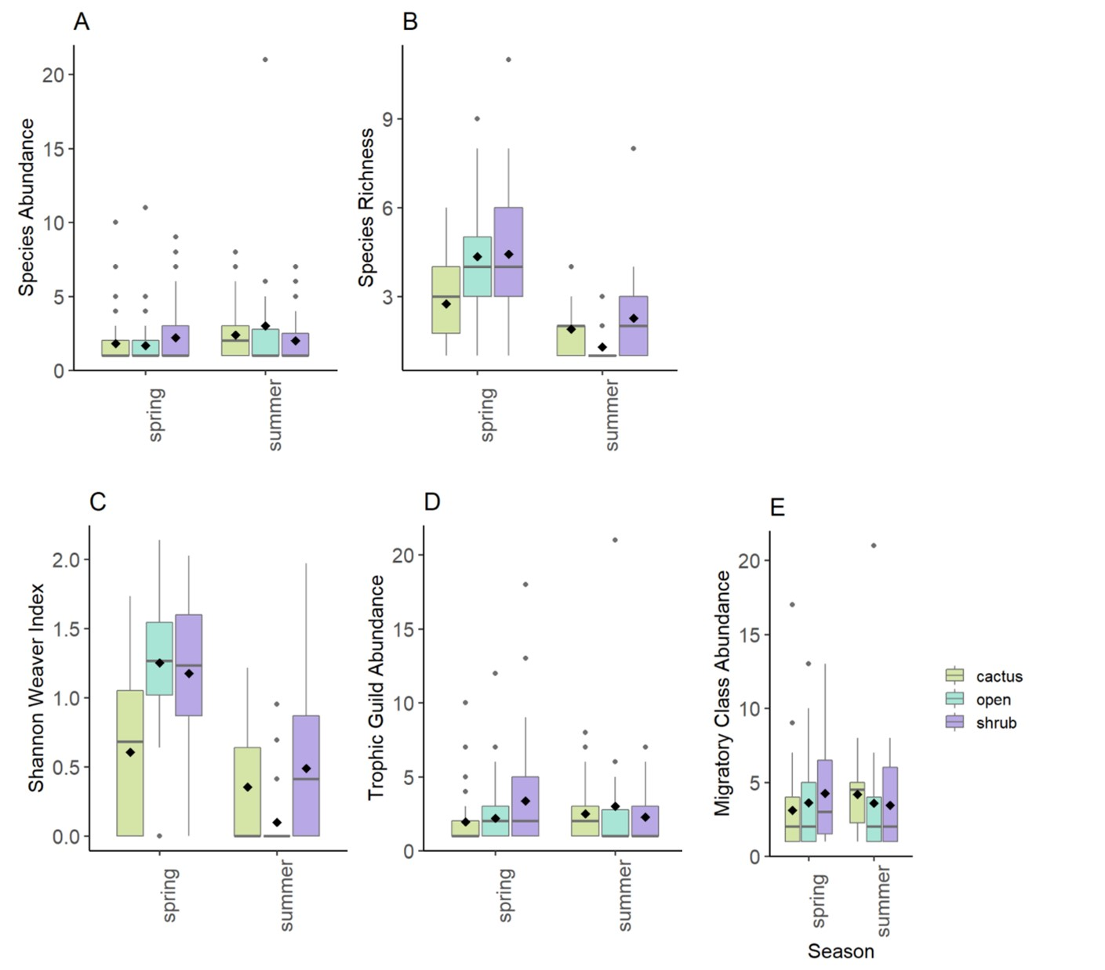

**Figure 2**. Boxplots of (A) species abundance, (B) species richness, (C) species diversity as the Shannon Index, (D) trophic guild abundance, and (E) migratory class abundance of all visually observed birds at either cacti, shrub, or open microhabitats in both spring and summer. Black diamonds represent the means value among surveys of each bird community metric. Shrubs in spring had the highest species richness (p = 0.024) and species diversity (p < 0.0001) relative to all other seasonal microhabitats.

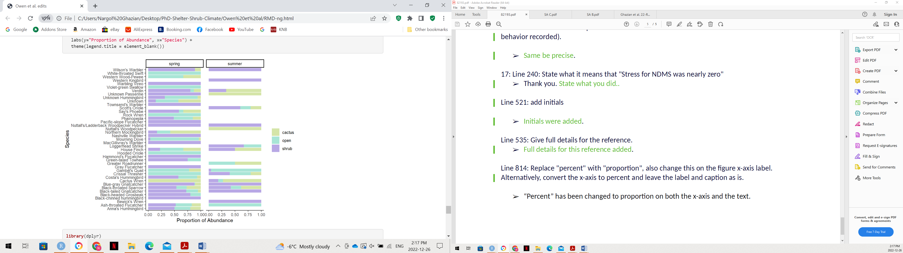

**Figure 3.** Species frequency as a proportion of all observed avian species at cactus, shrub, and open microhabitats during spring and summer. More species and more individuals were present in spring.

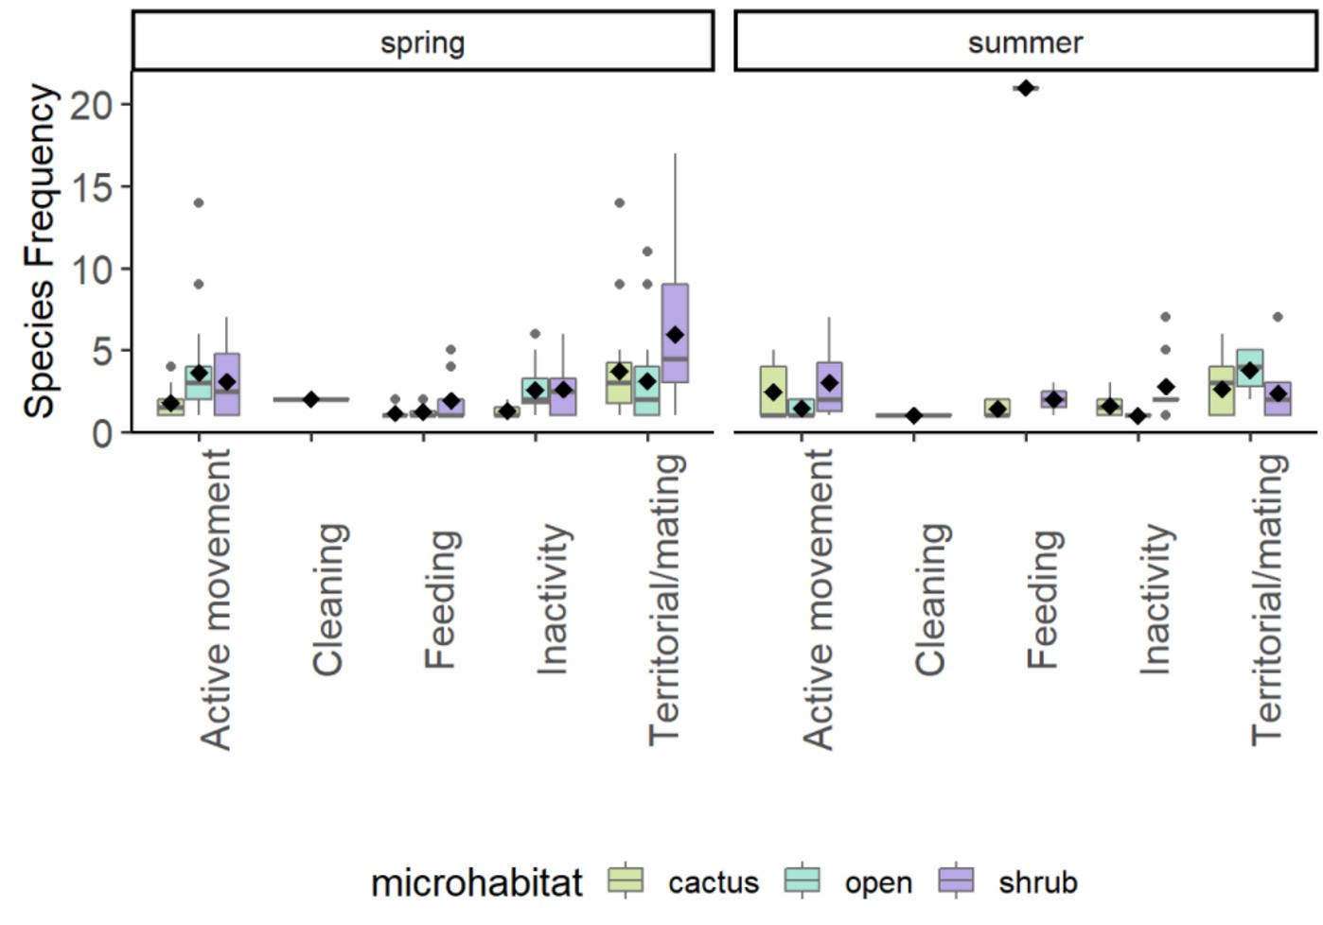

**Figure 4.** Boxplots of frequencies of behaviours exhibited by birds during surveys at cactus, shrub, and open microhabitats during spring and summer. Black diamonds represent the mean frequencies of each behaviour with survey as the level of replication. The most common behaviour exhibited at a single seasonal microhabitat was territorial/mating behaviours at spring shrubs (p < 0.0001).